scaled complementary error function

Def

$$erfx\left(z\right)$$

= $$1−erf\left(z\right)$$

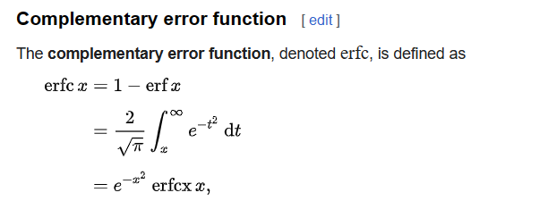

Approximation

For all $$z$$-> inf

=

[Faddeeva function - Wikipedia](https://en.wikipedia.org/wiki/Faddeeva_function)

Ref

[Error function - Wikipedia](https://en.wikipedia.org/wiki/Error_function)